Healthcare to patient:

* Telehealth
  + Already paired (100 million USD) up with venture ‘HEAL’ to provide telehealth services, we can provide additional/distinct services or skip altogether. <https://www.cnbc.com/2020/07/29/humana-invests-100-million-in-telehealth-start-up-heal.html>
  + The cost for a 30–90 minute house call is $159, although the typical cost to a patient is under $25, as most insurance plans cover the costs.
  + <https://www.unitedhealthgroup.com/newsroom/posts/2017-08-09-spotlight-on-julie-stewart.html> - Community Health Center of Southeast Kansas to start a new telehealth program, designed to connect more families who are living in the state's rural communities with care.
  + Partnering with community health councils of regions where there is a lack of primary care providers and the regions where patients would need to drive two to three hours for specialty care. Humana can enable these councils to provide telehealth to patients in such areas.
  + The Community Health Council of Wyandotte County has partnered with Kansas City CARE Clinic to train and manage the community health workers, who provide one-on-one services to address social and health needs. They help individuals and families access community resources for food or housing; apply for and utilize health benefits; find affordable health care and medications; attend doctor appointments; and get motivated to set and reach health goals. (<https://www.unitedhealthgroup.com/newsroom/posts/partnership-for-healthier-kansas.html> )
  + <https://www.unitedhealthgroup.com/newsroom/2020/2020-05-11-optum-behavioral-support-covid-19.html> Optum receives are for a telehealth visit. By the end of March, approximately 33% of all behavioral health claims for Optum members were for a telehealth visit.
  + Interactive platform provides the most up-to-date information about prevention, coverage, care and support needed to rapidly assess symptoms, schedule an in person or a telehealth visit with their provider, talk to a nurse, refill or schedule home delivery for prescriptions, and to access emotional support 24 hours a day. We are also adding a symptom checker that can help members review their symptoms quickly from the convenience of their own home and then guide them to the appropriate services. <https://www.unitedhealthgroup.com/newsroom/2020/2020-03-18-covid19-uhc-support.html>
  + 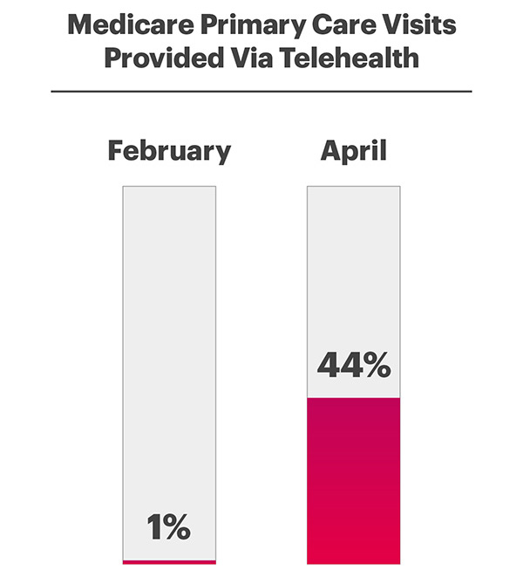UnitedHealth Group accelerated adoption of telehealth for communities at risk by supporting access to the internet and offered on-site logistical telehealth implementation support to key primary care and behavioral health providers. <https://www.unitedhealthgroup.com/newsroom/posts/2020-10-12-phil-mckoy-role-digital-tools-health-equity.html>
  + Check if HEAL provides both synchronous and asynchronous services

----------------------------------------------------------------------------------------------------------------------------

Digital Health Identity connected devices IOT remote health monitering

<http://www3.weforum.org/docs/White_Paper_Digital_Identity_Threshold_Digital_Identity_Revolution_report_2018.pdf>

Smart devices – from mobile phones to wearables and smart home assistants, connected vehicles and healthcare devices – are becoming integral to our daily lives. Gartner estimates the number of connected things in use worldwide will reach 20.4 billion by 2020.13 As we enter the Fourth Industrial Revolution, the complexity and number of connected devices transacting in the digital space will rise. Digital identity mechanisms will be of paramount importance for enabling trusted and secure transactions through these devices. This will require scalable, reliable and secure methods of allocating, authenticating and managing human and machine identities throughout the life cycle of each connected entity.27 Identity mechanisms need to evolve and scale to be capable of securely managing the identities of the anticipated billions of connected devices while enabling their usability. These identity mechanisms must address the challenges of scalability, governance, privacy, domain space, complex devices and machine relationships, including multiple infrastructure and device ownership models, and different access management mechanisms for both real and virtual machines. Technologies and architecture are already transforming and developing our relationship with these devices. This includes cryptography, as chip manufacturers embrace the need for it and implement architectures that support hardware encryption, secure execution and embedded chip identifiers.

Blockchain has the potential to be the backbone of internet of things (IoT) implementations in the future. Organizations are investing to develop IoT applicability for blockchain technology that will enable automated M2M communication and awareness while maintaining traceability, immutability and auditability of transactions performed by the device. A number of standards (e.g. ISO, ITU-T, IEEE) are being developed across different areas in IoT with the hope that interoperability and alignment between business objectives and risks of IoT and associated challenges with identity would be considered. Alignment between industry, end users, standards organizations and regulators would need to play a role to ensure the technologies are properly leveraged to bring IoT to its potential.

------------------------------------------------------

Digital Identity and telehealth  
<https://getid.ee/online-health-identity-verification-for-telemedicine-services/#:~:text=With%20the%20advent%20of%20Identity,is%20not%20utilizing%20stolen%20data.&text=In%20addition%2C%20healthcare%20providers%20can,patient%20via%20digital%20facial%20recognition>

.

## **How the Use of Identify Verification Can Improve Digital Healthcare Services**

It is clear that the telehealth and online medical providers need a flawless Identity Verification system to ensure the safety of the patients’ data and quick onboarding process. Healthcare providers and general physicians are usually not trained enough to protect patients’ online data.

With the advent of Identity Verification, telehealth professionals can authenticate patient identities via automated systems. It is an effective way to ensure that an individual is not utilizing stolen data. With the help of document verification, online healthcare services can easily identify patients.

In addition, healthcare providers can authenticate the credentials of a patient via digital facial recognition. It allows telehealth providers to determine the true identity of a particular patient and offer the best possible care effectively.

# [**https://healthitsecurity.com/news/telehealth-adoption-requires-modern-identity-verification**](https://healthitsecurity.com/news/telehealth-adoption-requires-modern-identity-verification)

# **Telehealth Adoption Requires Modern Identity Verification**

**Efficiency**

**User Experience**

**Data Privacy**

**Compliance**

**Fraud Deterrence**

[**https://www.pymnts.com/digital-identity/2020/why-pandemic-is-changing-digital-identity-importance-healthcare-world/**](https://www.pymnts.com/digital-identity/2020/why-pandemic-is-changing-digital-identity-importance-healthcare-world/)

**Important article**

<https://www.healthcareittoday.com/2020/06/09/deploying-digital-identity-solutions-in-healthcare-is-long-overdue-with-the-current-crisis-it-is-more-critical-than-ever/>

These verification checks, including document authentication and facial recognition match, can be added on to validate patient identity in one seamless workflow. Facial recognition can then be used to login to patient portals and even while administering care to prevent patient mismanagement. Automating the intake process enhances the operational efficiency, security, and the patient experience.

With proper affirmative consent, patient data can be remotely captured from medical insurance cards and government issued IDs. The patient’s electronic health record (EMR) is quickly auto populated with both data and images to keep accurate records.

----------

* Chronic Diseases and Behavioral Health:
  + Healthcare utilization is more than twice as high among chronic disease patients as among those without chronic disease; inpatient utilization is as much as four-fold higher. Chronic conditions compound the stress on patients to attend frequent appointments, undergo regular diagnostics, and maintain complex medication regimens.
  + Solutions:
  + ● Enabling home-based diagnostics and equipment
  + ● Virtual applications, interoperability with systems of engagement (for example, electronic health record, revenue cycle, digital front door) and supporting infrastructure.
  + ● Blood glucose monitors or Bluetooth-enabled blood pressure cuffs
* Low Income Access to Affordable healthcare:
  + According to the CDC, more than 13 million patients in 2017 went without care in just one year. The reasons why people are not able to avail the benefits of programs such as Medicare and Medicaid can be attributed to the lack of awareness about their eligibility to avail such benefits.
  + Solutions:
    - ● Increase awareness of telehealth as a convenient, and affordable method of treatment for the elderly and people in rural area and people with low income
    - ● **Reach to accessible, cheap gadgets and technology devices** such as smartphone and tablets possessed by some family members
    - Free Internet access through community wifi hotspots or libraries
    - Assess **awareness** campaign **success viability and costs, method of campaigns** based on comparison with other campaigns targeted towards similar audience
* Ambulatory, Acute & Routine Test Workflows:

Our model suggests a high contribution of Count of Logical Claims for Ambulatory Services, Medical and BH Ambulance Visits, Routine Venipuncture and VCO Exams towards the prediction of Transportation Issues. Virtual healthcare includes clinical assessment and treatment for non-life-threatening concerns reducing the pressure on ambulatory and Medical Testing services Solutions:

● Telephone triage - disposition of symptoms via smartphone by experienced clinicians and licensed medical professionals.

● Problem-solving strategies eg: pattern recognition, assessment to formulate a working diagnosis.

● Electronic intensive care unit (e-ICU) programs, allowing nurses and physicians to remotely monitor the status multiple patients in ICUs in multiple hospitals

● On the wheel Medical Testing Facilities

* Secure Digital Identity and blockchain based services (CORE):
  + Implementation - costs, blockchain architecture(consensus mechanism), integration of each stakeholder on the platform. In a table form
  + Tie up other aspects with digital identity
  + Visualization

Bringing Patients to Healthcare:

Community health workers:

* Make it easier to access and schedule already existing STATE transportation service. Increase awareness of the patients about the NEMT service and provide a user-friendly and optimized scheduling application, with less wait times. Access to such service would have a profound impact on resolving the transportation issues for patients largely unaware of such service.
* Make it easier to connect with/contact community health workers
* MAP if feasible
* Chronic patients can have their check up appointment scheduled in advance and the doctors/nurses should encourage, or maybe even deploy their own resources (social service) for such patients

Healthcare for Disabled:

* Humana can deploy awareness and information programs to educate specifically the disable people about healthcare services, catering to their special needs.

DIGITAL IDENTITY

Creating a digital identity:

https://www.accenture.com/_acnmedia/PDF-73/Accenture-Building-A-Trusted-Identity.pdf#zoom=50

At an enrollment station, his biometrics are securely captured through his fingerprints, voice, face or an iris scan. Then several steps are taken to create a unique identifier using multiple security protocols. This identifier is then recorded on the blockchain which acts as an index with links to all applicable data. This makes it easy to locate, access, and share information without Yousef’s [personal data being stored on the blockchain

Using an application on his phone, Yousef creates a personal profile that is multi-factored and authentication secured. The app allows Yousef to generate his own set of public and private keys which he can use to sign the data he sends to others. That way third parties can be absolutely certain the information is his. Yousef shares the public key using a QR Code. When he scans his QR Code at the enrolment station an official attestation is added to his profile and signed by a private key. This is the beginning of Yousef’s living identity, an identity that he will build with each stamp he collects from his university, his employer or from government and non-government agencies. The major benefit of this identity system is that Yousef is always in control of his own personal data. He determines which information is shared, who seed it and for how long. Instead of multiple paper documents, he can use a single, easy to use and manage app. The system makes life easier for organizations too: It’s interoperable with other databases so existing identity data stays put. Efficiency for background checks is greatly improved, as an organization can choose to trust existing attestations instead of repeating the process. For additional security, there’s also the option of checking data at source if the user grants permission.

---------------------------------

Find a way to include the HEAL acquired startup, and link it and its telehealth services with our digital identity platform (blockchain)’

Some states recognize smart contracts as legal agreements, overlap with humana operation states

<https://www.himss.org/resources/blockchain-healthcare>

* Secure Digital Identity and blockchain based services (CORE):
  + Implementation - costs, blockchain architecture(consensus mechanism), integration of each stakeholder on the platform. In a table form
  + Tie up other aspects with digital identity
  + Visualization

<https://hbr.org/2020/06/what-blockchain-could-mean-for-your-health-data>

1. Prevention of data silos’- We can’t use our own data to plan our lives and long-term healthcare: our treatment plans, the pharmaceuticals and medical supplies we use, our insurance or Medicare supplements, or how we use our health savings accounts. All these data about us reside in other people’s silos — in the separate databases of myriad healthcare providers, pharmacies, insurance companies, and local, state, and national agencies — which we can’t access but *third parties* like the American Medical Collection Agency ([AMCA](https://www.ciodive.com/news/healthcare-third-party-data-protection-compliance/573623/)) can, and often without our knowledge.
2. Prevention of risk of being hacked/ more secure given humana was hacked
3. Monetization of data could increase (profit for humana) as user feel they have more control and readily consent for data use, could be used to design a reward mechanism for the user to consent data which would lead to much more consent and less legal challenges and more profit (also increase trustability of the corporation )
4. Long term mandate regarding consent already in place in mindset, PSD2 and GDPR

### **patient control over health records could expedite data for treatments**

[**https://www2.deloitte.com/us/en/pages/public-sector/articles/blockchain-opportunities-for-health-care.html**](https://www2.deloitte.com/us/en/pages/public-sector/articles/blockchain-opportunities-for-health-care.html)

**Blockchain as an enabler of nationwide interoperability**

The Office of the National Coordinator for Health Information Technology issued a shared nationwide interoperability roadmap, which defines critical policy and technical components needed for nationwide interoperability, including:

1. Ubiquitous, secure network infrastructure
2. Verifiable identity and authentication of all participants
3. Consistent representation of authorization to access electronic health information, and several other requirements.

However, current technologies do not fully address these requirements, because they face limitations related to security, privacy, and full ecosystem interoperability.

----------------------------------------------------------------------------------------------------------------------------

<https://www.forbes.com/sites/cognitiveworld/2019/11/04/adoption-of-ai-and-blockchain-at-hhs-interview-with-jose-arrieta-us-department-of-health--human-services-hhs/?sh=3a20cd72385d>

Replicate similar strong use case for humana - ask plaksha

**US Department of Health & Human Services (HHS) Leading the effort to implement blockchain in healthcare**

HHS is a very large agency with over $1.1 trillion dollars of impact on US GDP. The agency is there to protect the human condition from infectious diseases. With AI and blockchain technology, Jose is looking into deriving insights to drive costs down as it relates to operating and protecting the human condition and save human lives. As a large organization with over a million contracts issued over an 18 month period, Mr. Arrieta realized it would be helpful to get an understanding of the contract activity that is occurring across the HHS portfolio.

However, one of the challenges is that HHS is decentralized to the point that it is hard to get this level of visibility without trying to centralize the organization, an effort which would be futile given the amount of varying processes within each department of HHS. The agency has five contract systems which can be hard to manage. Arrieta’s team layered these systems with a blockchain approach to pull all the data from the contracts and cleansed the data. While those contract systems are still operating, they have formed a platform and data layer to modernize business processes and create analytical insights to drive value for the people negotiating the contracts for HHS. Next, Arrieta and his team wireframed out the entire lifecycle of the acquisition process to make sure that they are only collecting information one time versus multiple times by prior applications.

His team also built an AI model using microservices that occur right off the data layer. This microservice uses natural language processing and machine learning to analyze prices paid and read through the terms and conditions of a contract. This allows for the model to quickly analyze these contracts and determine the range of the terms and prices. It is an incredibly powerful tool that is showing immediate savings - it’s able to perform work that would have taken a human several months of time in just a few seconds.

**This article also has important information about how one would go about the adoption (maybe implementation) of blockchain**

1. **To tackle Data and privacy concerns: they are using a model based of off non-private data to establish a proof of concept:**

Data is at the heart of AI, and in general the more data you have, the better. Data is what allows algorithms to “learn”. However, concerns around data usage and privacy are steadily growing. It’s no surprise then that there has been some pushback on AI and blockchain’s use of data when it comes to privacy. As a result, Arrieta and his team aren’t starting blockchain and AI-based projects where the data is most sensitive and where they need to be the most careful. They are starting with procurement to figure out how to be more efficient for the taxpayer by buying things in a better way. This area has a minimal privacy risk allowing the team to start in a more controlled environment to learn how the technology works. In procurement, this data is collected already so it’s more of a way to show and demonstrate a proof of concept. It is important to look at better ways to protect data as so many bad actors is seeking this data. Arrieta advocates to look to these technologies to protect the data. Take the lessons learned from the projects with non-sensitive data and apply it to technologies for use with sensitive data.

**Hyper Personalized Pattern**

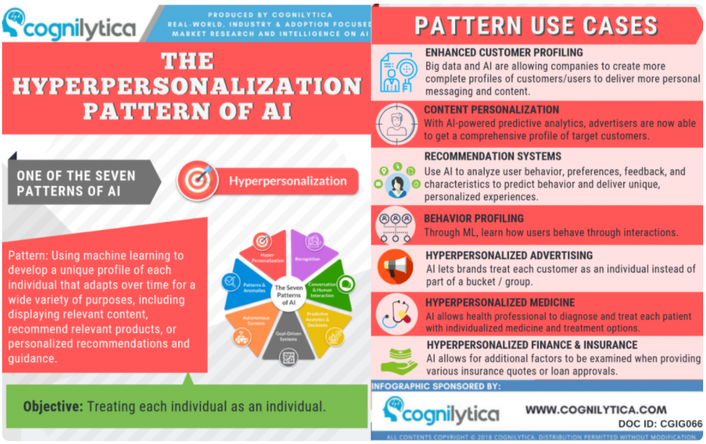

**Point 7: Hyperpersonalized Finance & Insurance**

**The biggest benefit blockchain provides is allowing stakeholders to collaborate more effectively without compromising each company’s intellectual property, according to Ronanki.**

**Advantage of blockchain technology for Supply chain enhancement:**

North America to Witness the Highest Growth

– In the US, the FDAs Drug Supply Chain Security Act outlines requirements to develop and enhance drug supply chain security by 2023. These developments are good news for blockchain industry as the companies try to manage product quality and security.

– Major U.S. healthcare companies have formed an alliance called Synaptic Health Alliance, That group is making progress on a pilot program to use the distributed ledger technology to improve the accuracy of healthcare provider data.consists of Humana, Multiplan, UnitedHealth Group’s Optum, UnitedHealthcare, Quest Diagnostics and Ascension to trial blockchain solutions in order to improve data quality and reduce costs,

– According to Centers for Medicare & Medicaid Services, at least half of the information on Medicare Advantage Organizations contained mistakes, which affects customers by causing delays in medical services and can make them subject to fines.

– In Boston, medical offices use more than two dozen systems for keeping electronic health records. This makes them prone to frauds and hacking.

– Ageing population and rising healthcare costs indicate higher healthcare spending in the US. Thus blockchain offfers a potential solution to safegaurd patient and clinical data.

HUmana is already a part of a blockchain alliance so this falls in line with that alliance

SYNAPTIC ALLIANCE:

## [**https://www.synaptichealthalliance.com/project**](https://www.synaptichealthalliance.com/project)

## **Through the “provider data exchange” enabled by blockchain technology, Alliance members were able to find and update certain demographic inaccuracies faster than they would on their own.**

Federal regulations require insurers to maintain directories that contain up-to-date demographic information about physicians and other providers, such as name, address, specialty and phone number. Typically, each insurer maintains its own directory, which can be a time-consuming and expensive endeavor. If the information in these directories is inaccurate, it can delay claim and payment processing and can lead to fines from the Centers for Medicare and Medicaid Services (CMS). Roughly $2.1 billion is spent annually across the healthcare system chasing and maintaining provider data. Still, a review completed last year by CMS found that 52 percent of provider directory locations listed had at least one inaccuracy.

### **Pilot Results**

In its pilot, the Alliance used its blockchain functionality to identify up to 88% of necessary demographic data corrections across the Alliance members’ shared data for two of the most common errors in care provider directories:

* Inactive locations, which refer to sites of service where care providers were once seeing patients but are no longer doing so; and
* Address mismatches, which occur when health care organizations have differing addresses for the same care provider.

<https://www.cms.gov/files/document/humanacmp02282020.pdf>

Digital IDENTITY and increased transportation services awareness through blockchain consortium

**The biggest benefit blockchain provides is allowing stakeholders to collaborate more effectively without compromising each company’s intellectual property, according to Ronanki.**

The Synaptic Health Alliance group consists of Humana, Multiplan, UnitedHealth Group's Optum, UnitedHealthcare, Quest Diagnostics, and has recently been joined by Ascension — the largest not-for-profit health system in the U.S. according to Modern Healthcare — and CVS Health-Aetna, which has an estimated 22 million of members.

Comparative Case

**Together, these insurers would begin a trial of blockchain solutions intended to solve a variety of problems common to the health insurance industry.**

Chief among these problems is the inaccuracy of directory data, which provides insurers with information on medical providers, info that is obviously needed in order to accurately process claims. According to Modern Healthcare, **insurers and health care providers spend around $2.1 billion a year to keep this info updated**, while the Centers for Medicare & Medicaid Services reported last year that 52 percent of all provider locations listed in 64 online directories had at least one error in them. **By introducing distributed ledgers into this equation, providers will be able to quickly and cheaply share updated location (and other) info, thereby making it likelier that claims will be processed in a timely fashion.**

Bang! Quote from inside humana;

What’s more, Humana believes that using blockchain tech for this purpose would provide the best possible entry point for bringing blockchain to other areas of the industry, as explained to Cointelegraph by **Kyle Culver, the lead enterprise architect at Humana:**

In thinking about the opportunities with blockchain, **it’s important to know that its value proposition is driven by network effect, meaning that the value of a blockchain-powered solution increases as the number of participants using the solution increases.** Thus, at Humana, we are focusing first on the provider directory use case. **Provider directories rely upon public data, so the firms creating directories don’t view this activity as being competitive in nature. With the competitive risk mitigated, firms have been more willing to collaborate. There are many other similar opportunities ripe for collaboration that could improve the overall healthcare system**

**Humana could use this consortium, form new consortium per state or all over to mitigate the transportation related problems, by increasing collective awareness about the state’s public (Medicare or Medicaid programs) transportation services and access, by running digital awareness campaigns.**

**Telehealth:**

**A Heal house call is unlike any doctor's appointment you've had before. An unhurried, caring doctor will take the time to learn your health history in order to develop a care plan for you, and not just the issues you face at the moment. Health history can be instantly accessed on blockchain, if a patient has a digital identity.**

**EMR record management using blockchain:** [**https://www.nature.com/articles/s41746-019-0211-0**](https://www.nature.com/articles/s41746-019-0211-0) **Blockchain vehicles for efficient Medical Record management**

[**https://www.unitedhealthgroup.com/insights-solutions/the-path-forward.html**](https://www.unitedhealthgroup.com/insights-solutions/the-path-forward.html)

**-----------------------------------------------------------------------**

**https://www.healio.com/news/infectious-disease/20201023/id-telehealth-services-expand-providing-viable-alternative-for-care**

**Infectious diseases: ID telehealth services expand, providing ‘viable alternative’ for care**

**Improves no-show rate :  
whereas the no-show rate in the general infectious diseases group decreased from 9% to 4%.**

**‘Viable alternative’**

**Telehealth Challenges and barriers —**There are many technical barriers to telehealth services. Adequate internet capability, whether wired (ethernet) or wireless, of the provider and patient is essential and determines the speed and image quality in demonstrating wounds to the provider. Some patients are unable to download the appropriate applications owing to the age of their devices. Older devices have less memory capacity for the newer apps needed for telehealth. Increasing the broadband capability allows faster transmission of video images and less "freezing." Poor image quality makes it difficult to provide a proper diagnosis.

Patients who lack resources for data transmission and photos via a smartphone may resort to correspondence via the hospital or patient portal system, if available. The patient can email photos or discuss their concerns directly with their provider over the phone (ie, telephonics). With email, there may be delays in transmission of patient health information due to its encryption.

It is also important to note that coding and billing reimbursement for telephonics differs from telehealth face-to-face visits.

# 

# **Telehealth Claims Spike More Than 8,000% Amid COVID-19 Pandemic, Government Waivers (verify)**

**https://skillednursingnews.com/2020/07/telehealth-claims-spike-more-than-8000-amid-covid-19-pandemic-government-waivers/**

**But the challenge of social determinants also requires a more systemic change in health care. That’s why earlier this year UnitedHealthcare, in collaboration with the American Medical Association (AMA), proposed an expansion of the ICD-10 billing codes used by health care providers to include social factors that contribute to patient well-being, such as food, housing, transportation and other social services. Health care providers are key to identifying those most in need of assistance, and using the new codes would trigger referrals to social and government services that can help address an individual’s unique needs.6**

**The proposed new codes provide more specific diagnoses pertaining to a variety of social factors, including access to food, housing, transportation, utilities and personal caregiving needs.**

[**https://www.uhc.com/employer/news/client/how-employers-can-address-social-factors-in-employee-health-care**](https://www.uhc.com/employer/news/client/how-employers-can-address-social-factors-in-employee-health-care)

[**https://www.businessinsider.in/science/unitedhealthcare-and-the-ama-are-developing-new-billing-codes-for-social-determinants-of-health/articleshow/68711300.cms**](https://www.businessinsider.in/science/unitedhealthcare-and-the-ama-are-developing-new-billing-codes-for-social-determinants-of-health/articleshow/68711300.cms)